**Read Me:**

**Airbnb – Dublin:**

This Airbnb data analysis project looks at customer behavior and preferences to improve the booking process. The analysis identifies the top countries with the most searches and examines room availability, preferred room types, and booking lengths. Recommendations include offering special prices for stays of varying lengths, creating deals based on what customers like, and offering promotions for rooms booked without prior searches. These insights can help Airbnb improve its business and make customers happier.

**Business Questions:**

* From which countries will the highest number of searches originate?
* What was the room availability the guests searched for?
* What is the most searched room type?
* For how many nights the guests were searching for a room?
* Which countries have actually placed real orders?

**Recommendation:**

* Special price for residents of Ireland who are placing an order for less then a month.
* Special price for residents of all countries placing an order for less then a month and a half.
* 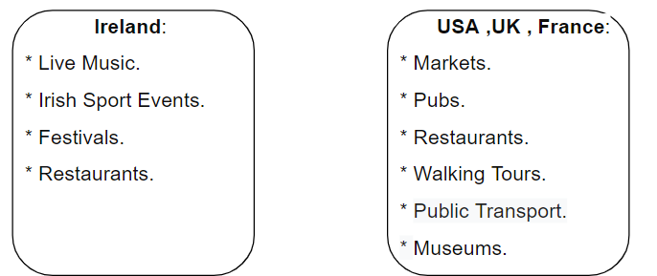offering guests deals on rooms/ apartments near attractions and activities that suit their preferences:
* תמונה שמכילה טקסט, צילום מסך, גופן, מספר

  התיאור נוצר באופן אוטומטיBuilding a pricing structure with special rates for minimum nights and for Entire home/apt room type:

* Creating a special pricing list for users who make immediate reservations without searching.